
The voice of social economy enterprises and organisations in the EU

29 March- Save the date

Portuguese Presidency Conference on Social Economy

The Portuguese Presidency of the Council of the EU, which has made of strengthening social Europe to deliver a fair, green and digital recovery, organises a high-level conference on The role of Social Economy in the creation of jobs and the implementation of the European Pillar of Social Rights, to be held on Monday 29 March, from 11:30 to 17:00 CET, as a digital event, livestreamed from the National Palace of Queluz in Sintra.

Please find here the agenda of the event
More information on how to follow this event will be shared soon through the websites of the organisers (Portuguese Presidency in cooperation with CASES) and through SEE website and social media.
The high-level conference which serve to present the Network of Portuguese Cities that will be European Capital of Social Economy in 2021, as well as to continue the debates on co-building the European Action Plan for the Social Economy.Save the date and stay tuned!

Farewell to Dr. Ulla Engelmann as Head of Unit for Social Economy at DG Grow
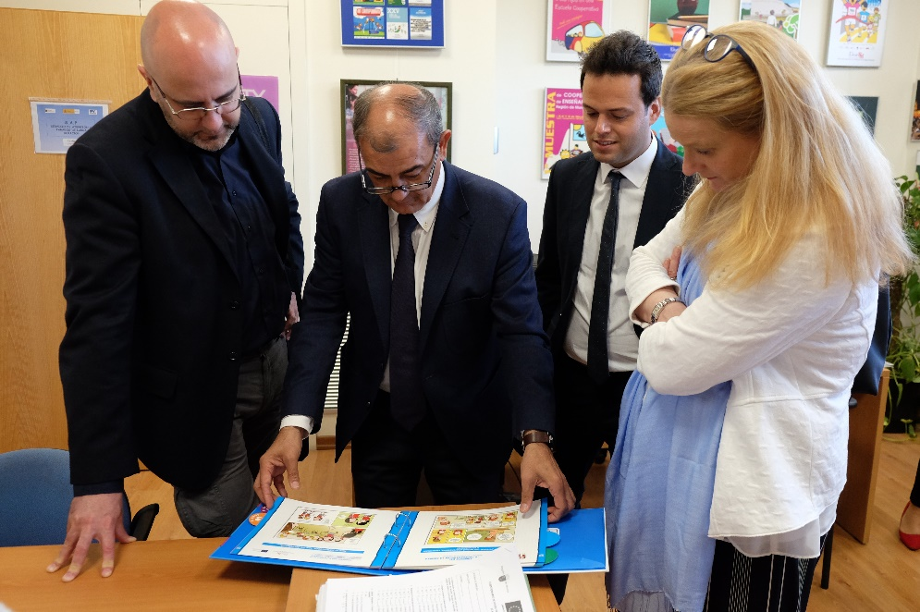
Dr. Ulla Engelmann has just changed responsibilities within DG GROW. From today onwards she is Acting Director for networks and governance and Head of Unit for industrial forum, alliances and clusters. A unit responsible for the Enterprise Europe Network and Erasmus for Young Entrepreneurs: very relevant areas for the Social Economy.
SEE President Juan Antonio Pedreño has declared: Cooperating with Ulla during the last four years has been not only a pleasure but also a privilege for the whole social economy community. Ulla has led a highly professional and motivated team that has opened up many new opportunities for the development of the Social Economy. We look forward to maintaining the cooperation to keep supporting social economy enterprises, orgaisations and entrepreneurs.
Dr. Ulla Engelmann also declared: I want to thank all Social Economy stakeholders for the engaged discussions and interactions which we had during the last 4 years. I’m looking forward to the many ideas which we planted together to blossom, I’ll be continuing in my new function to be a partner for you.
The new Head of Unit for Proximity, Social Economy and Creative Industries within DG Grow is Ms. Anna Athanasopoulou, whom SEE welcomes and wish all the best in this new chapter.

